**Project CleanSweep**

Team Name: 6ixSheets

|  |  |
| --- | --- |
| Member | Email |
| Grant Abbondanza | gsa5054@psu.edu |
| Christian Brand | cdb5418@psu.edu |
| Adina Lamboy | arl5500@psu.edu |
| Stuart Perry | ssp5204@psu.edu |
| James Ringler | jhr5148@psu.edu |
| Kyle Weldon | kaw5382@psu.edu |

Project Advisor:  Michael Melusky, mcm297@psu.edu

Project Description:  Our team will be developing a room cleaning optimization program. This program will be used by the maids and front desk staff to maintain orderly and efficient cleaning, accommodate guest requests, and minimization of dead time between when a room is cleaned and when a guest can check in. This program will be a windows application that is based at the front desk and maids will use an android application to receive the most up-to-date information regarding customer requests, last minute changes, and the order rooms should be cleaned.

Member Responsibilities:

Kyle Weldon:  Project Leader / Android Application Developer

Grant Abbondanza:  Desktop Application Developer

James Ringler:  Desktop Application Backend / Database Developer  
Adina Lamboy:  Desktop Application Developer

Stuart Perry:  Android Application Developer

Christian Brand:  Android Application Developer

GitHub:  https://github.com/xblGrant/CleanSweep.git

High-Level Functional Requirements:

* Types of Users
  + Manager (Admin)
    - Only account who can inspect a Room
    - Only account who can add Incident
    - Only account who can verify an Incident has been resolved
  + Employee(Maid)
    - Cleans Room
    - Report Incident
* Miscellaneous
  + Assignment History
    - History of which Employee was assigned to a given Room
    - Employee handles/cleans all Incidents to Room they are assigned.
    - Information only kept for an allotted amount of time.  (Maybe 1 week)
  + A Room has an Assigned Status
    - True if assigned to an Employee for cleaning, otherwise false
  + A Room has Reservable Status
    - Determines whether a given Room is a Reservable Room or Non-Reservable Room
  + A Room has a Room Status based on if it is reservable or not.
* Manager Tasks
  + Desktop Application
    - Daily things to be generated automatically
    - Wake-Up Call List
    - Generate list of departing customers (Departing Guest List)
      * + Auto update Departure Status for Reservable-Room

On-Time

Late

* + - * Generate list of rooms requesting cleaning (Clean List)
        + Auto update Room Status
      * Assign Rooms to Employee (Cleaning Assignment List)
      * Generate Incident List(daily hotel issues/problems)
        + Auto update Incident Status to Room
    - On-Request Functions
      * Insert a Wake-Up Call to Reservable-Room
      * Sync & Add Guest Reservation (w/ comments)  [Excel File | CSV]
        + Group Reservation

Application finds most logical set of rooms to put Group

* + - * + Allocate blocks of time that states the Room Status

Reservable

Available

Occupied-Clean

Occupied-Dirty

Do Not Disturb

Vacant-Clean

Vacant-Dirty

Non-Reservable

Clean

Dirty

* + - * Track Guest to keep previous Service Comments
        + Allow comments by Manager
      * Manager checks-in a Guest
        + Notifies application when room is occupied
      * Manager checks out a Guest
        + Notifies application when room is unoccupied (Vacant-Dirty)
        + Notification that Guest hasn’t checked out on time
      * Generate list based on open rooms for reservation (Open Reservable-Room List)
      * Update/Manage Clean List
      * Generate list based on rooms needed to be inspected (Inspect List)
      * Add Incident for a specified Room
      * Add Room
  + Android Application
    - Change Room Status to ready
* Employee Tasks
  + Android/Web Application
    - Generate Cleaning Assignment List for each Employee daily
    - Change Room Status
      * Via input from source such as tablet
      * Only admin can submit ready status for a Room
    - Display list of Rooms in hotel
      * Include whether Room has an Incident
      * Include Room Status (vacant-dirty, vacant-clean, ready, occupied)
    - Display list of all Room Incidents
      * Assigned Incidents per user
      * Incident List
    - Allow reporting of Room Incidents
      * Track Employee who reported Incident

Project Glossary:

* Manager:  A user with admin privileges
* Employee:  A user with basic privileges
* Guest:  A customer who rents a room
* Group:  Two or more guests who rent one or more rooms as a collective
* Room:  A defined area within the hotel
  + Reservable Room:  Room that is able to be reserved by a guest or group
    - Assigned Status:  Boolean field that is true if room is assigned to an employee, otherwise false.
    - Departure Status:  State of departing room
      * Late:  Guest or group is past the checkout time for assigned room
      * On-Time:  Guest or group is within checkout time for assigned room
    - Room Status:  A state that a room is in
      * Vacant-Dirty:  Guest has checked out and room needs cleaned.
      * Vacant-Clean:  Guest has checked out and the room has been cleaned.
      * Ready:  Room is ready to be assigned to another Guest
      * Occupied-Dirty:  Room is reserved and needs daily cleaning
      * Occupied-Clean:  Room is reserved and has been cleaned
      * Do-Not-Disturb:  Guest has Do-Not-Disturb on door, therefore room should not be cleaned.
    - Wake-Up Call:  A phone call to room at specified time
  + Non-Reservable Room:  Room that is not able to be reserved but is available to guests or groups
    - Room Status:
      * Dirty:  Room needs cleaning.
      * Clean:  Room has been cleaned.
  + Incident:  A special cleaning or maintenance related event in a specified room
    - Status:  Resolved status of Incident
      * Resolved
      * Unresolved
    - Comments:  Description of Incident
  + Service Comments:  Comments to define ambiguous and hotel specific room requirements
* Database:  Database that contains records of all Managers, Employees, Guests, Rooms, and Incidents
* Objects:
  + Assignment History:  Collection of information about which Employee was assigned a given Room.
* Generated Lists:
  + Open Reservable Room List:  Rooms available to be reserved by a Guest
  + Clean List:  Rooms that need to be cleaned.
  + Cleaning Assignment List:  Rooms assigned to individual Employee to be cleaned.
  + Inspect List:  Rooms that manager needs to inspect
  + Incident List:  All incidents currently not resolved.
  + Wake-Up-Call List:  Rooms that have requested a Wake-Up Call
  + Departing Guest List:  All Guests whose reservation is ending on the current day.
  + Assigned Incidents:  Incidents that are assigned to a specified employee
  + Group Room List:  List of rooms that a group is assigned to
  + Room List:  List of everyone room in the hotel

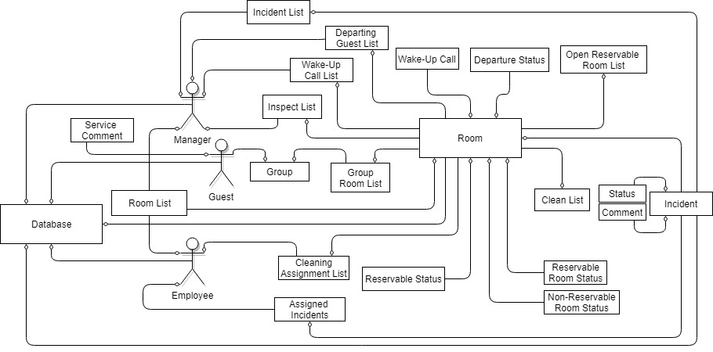

Figure 1: Domain Model

Use Cases:

USE CASE: Assign Room to Employee

BASIC COURSE:

        An Employee clicks Assign Rooms Button and then the system generates the Clean List. The system evaluates the first Room’s, in the Clean List, Assigned Status.  The system adds the Room to an Employee’s Cleaning Assignment List and changes the Assigned Status of the Room to true.  The system adds the Employee’s information to the Assignment History and repeats the process for each Room in the Clean List.

ALTERNATE COURSES:

**Room already assigned to an Employee:**  The system skips the current Room and iterates to the next Room in the Clean List.

**Assignment History contains another Employee’s information:**The system checks the other Employee’s Cleaning Assignment List for Room.  If Cleaning Assignment List contains Room, the system removes Room from current Employee’s Cleaning Assignment List.  If other Employee’s Cleaning Assignment List does not contain Room, the system replaces other Employee information with current Employee information in Assignment History.

USE CASE: Employee Cleans a Room

BASIC COURSE:

The Employee selects a Room from their Cleaning Assignment Screen. The system displays the Room Screen. The Employee selects the Clean Room Button. The system updates the Room Status of the Room.

ALTERNATE COURSES:

**Room has an Incident and is unable to be cleaned**: The Employee Reports Incident use case is invoked.

**Room is unable to be cleaned due to time constraint**: The Employee selects the Room Selection Button and returns to the Room Selection Screen.

USE CASE: Manager/Employee Reports Incident

BASIC COURSE:

The Manager/Employee selects a Room from the Room List. The Employee selects the Add Incident Button. The Manager/Employee inserts a Comment to the Incident describing the problem. The system changes the status of the Incident to Unresolved.

ALTERNATE COURSES:

**Incident is already reported for a certain room:** The System invokes the Update Incident use case.

USE CASE: Employee Inspects Room

BASIC COURSE:

The Employee selects a Room from the Room Selection Screen. The Employee selects the Add Incident Button. The Employee inserts a Comment to the Incident describing the problem. The system changes the status of the Incident to Unresolved and adds the Incident to the Incident List.

ALTERNATE COURSES:  
 **Incident is already reported for a certain Room**: The System invokes the Update Incident Use Case.  
Employee selects Cancel Incident Button and returns to the Room Selection Screen

USE CASE: Manager Resolves Incident

BASIC COURSE:

The Manager chooses a Room from the Incident List. The Manager selects the Incident Resolved Button. The system changes the Status of the room to Ready.

ALTERNATE COURSES:

**Incident is still Unresolved:** The Status of the Room remains Unresolved. If a Guest is assigned to a room, the system assigns them to a Room on the Open Reservable Room List.

**Incident is Resolved but room is not Ready:** The system updates the Room Status to Vacant Dirty. The system notifies the assigned Employee to clean that Room.

USE CASE: Manager Login

BASIC COURSE:

Manager enters Username and Password, then clicks the Login Button. System checks information entered is valid. System starts a Session and directs Manager to Manager Home Screen.

ALTERNATE COURSES:

**Username and Password Incorrect:** System redirects to Login Page. System prompts Manager to re-enter username and password.

**Username does not exist:** System directs Manager to Sign Up Screen.

USE CASE: Employee Login

BASIC COURSE:

Employee enters Username and Password, then clicks the Login Button. System checks information entered is valid. System directs Employee to Employee Home Screen.

ALTERNATE COURSES:

**Username and Password Incorrect:** System redirects to Login Page. System prompts Employee to re-enter username and password.

**Username does not exist:** System directs Employee to Sign Up Screen.

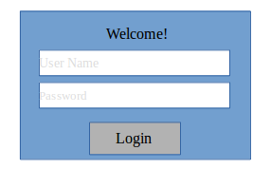

USE CASE: Logout

BASIC COURSE:

Employee/Manager selects the Logout Button. System will end the Employee/Manager session and the Employee/Manager is logged out.

ALTERNATE COURSES:

**User is not logged in:** System invokes the Login use case.

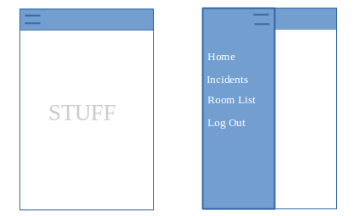

USE CASE: Register New User

BASIC COURSE:

A Employee/Manager inputs email and password. The system creates an Employee/Manager in Database. The system directs Employee/Manager to appropriate Home Screen.

ALTERNATE COURSES:

**Input is not valid:** System prompts Employee/Manager to re-enter a valid email and password.

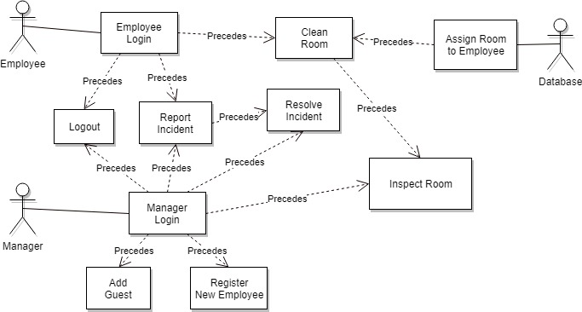

Figure 1: Use Case Diagram

Robustness & Sequence Diagrams:

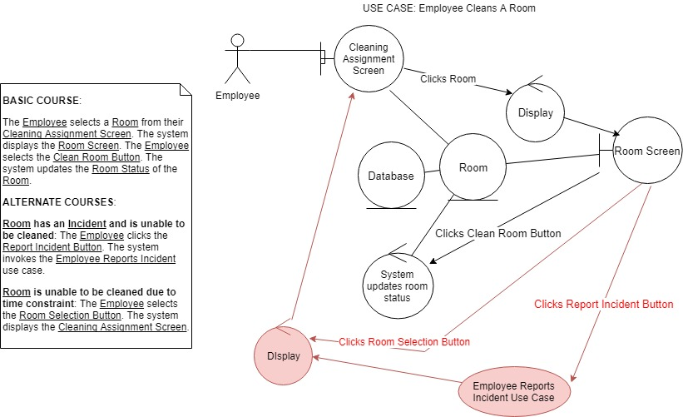

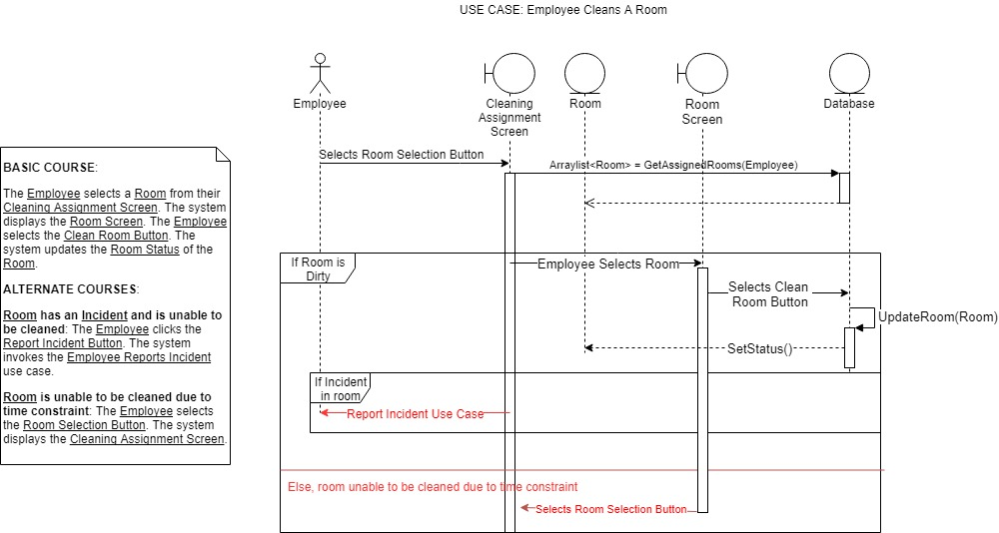

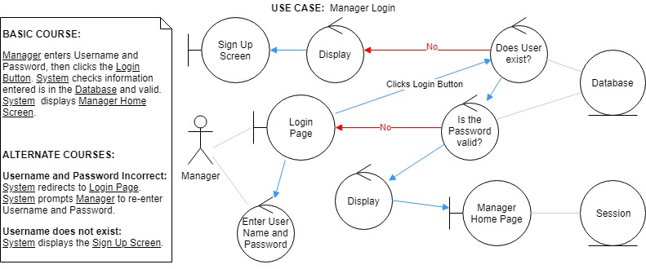

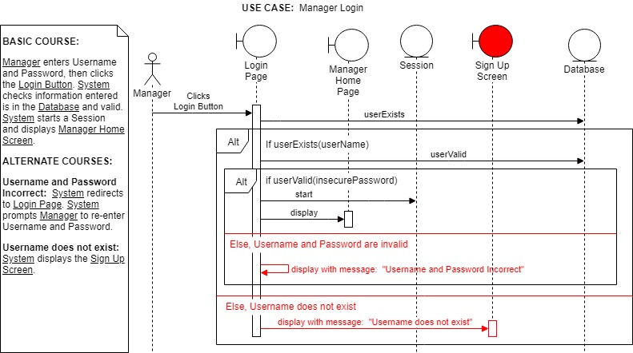

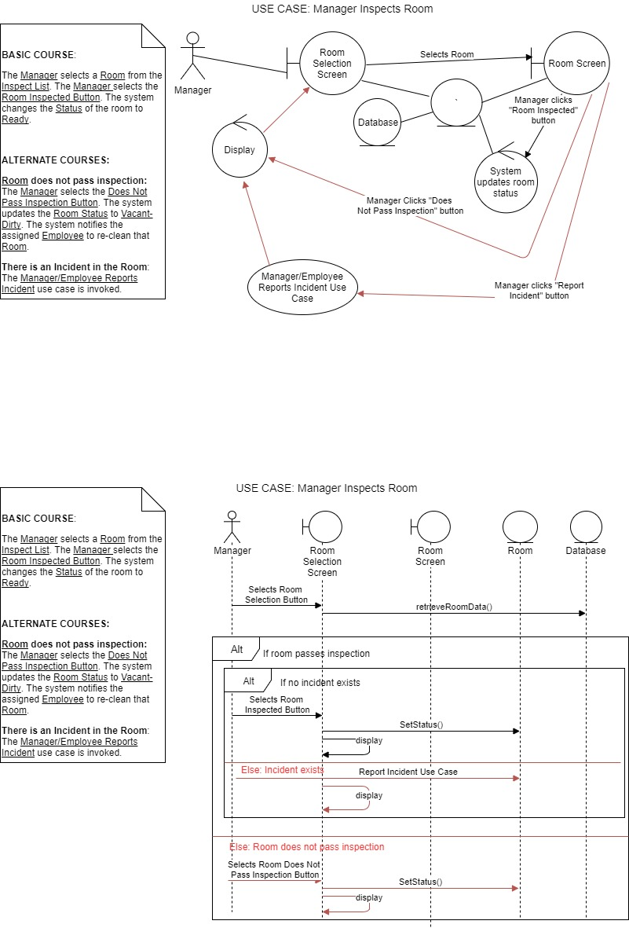

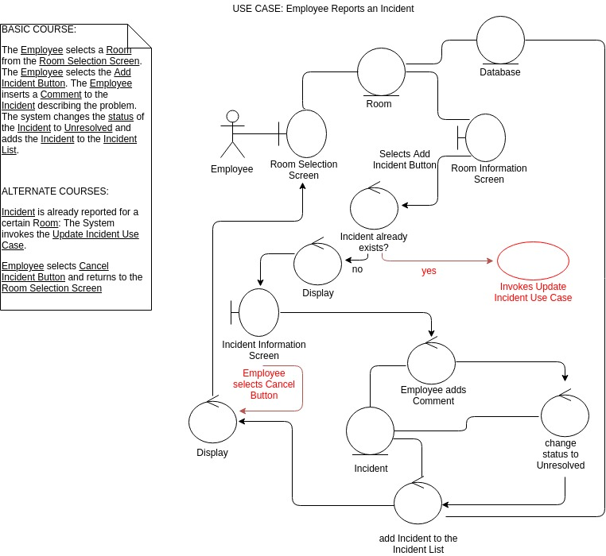

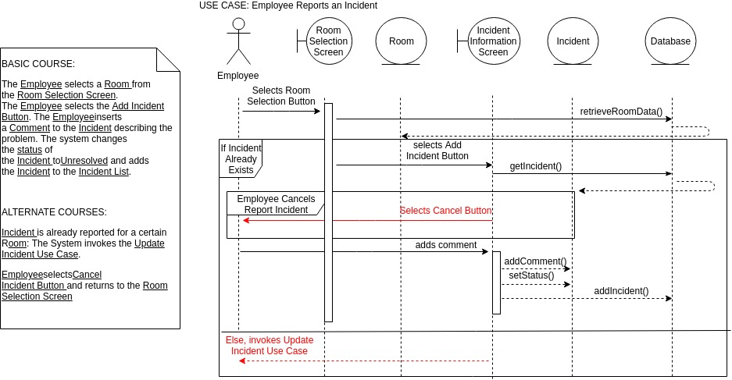

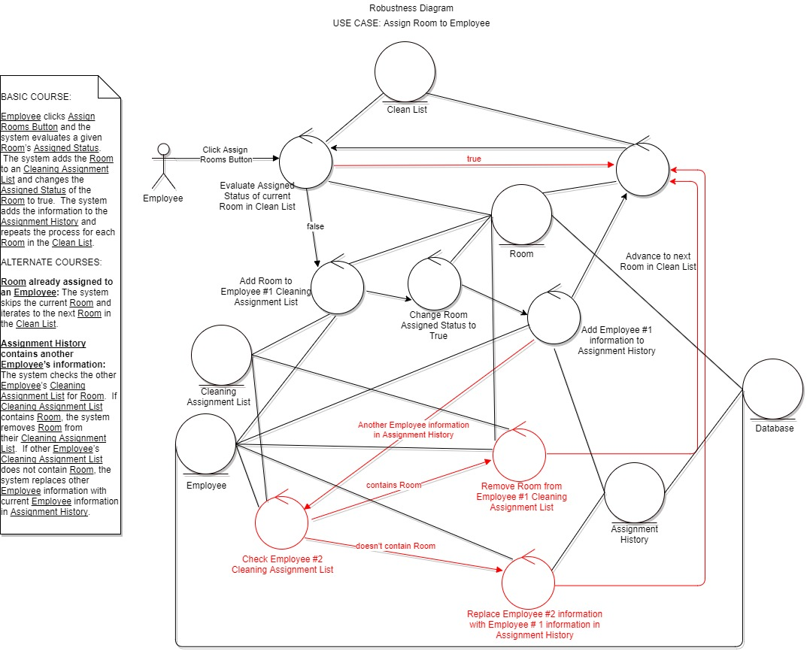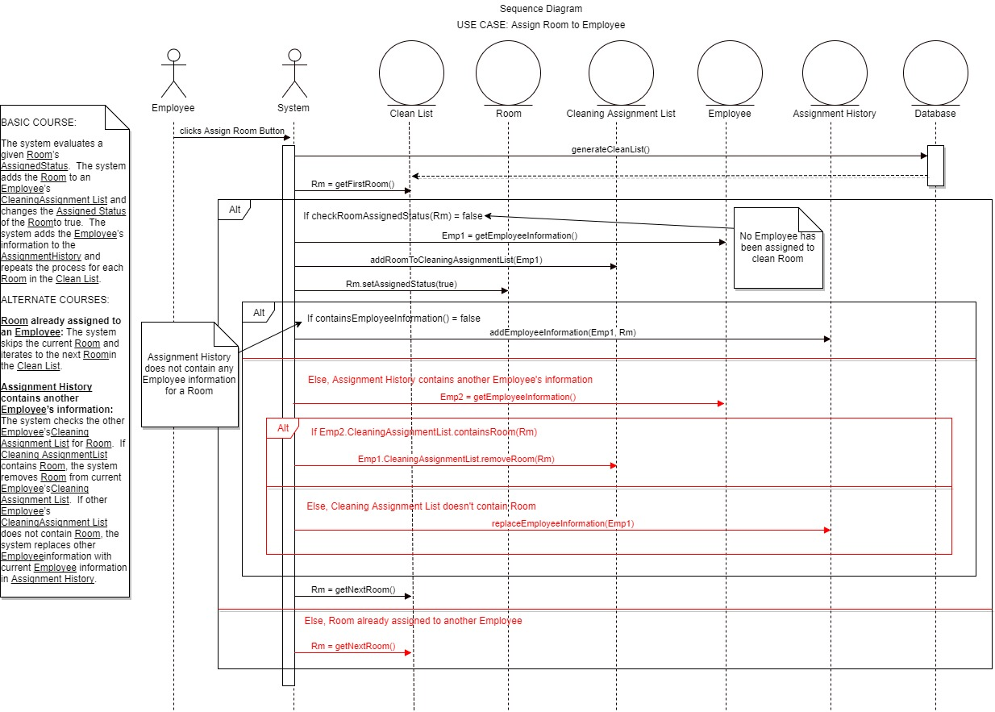

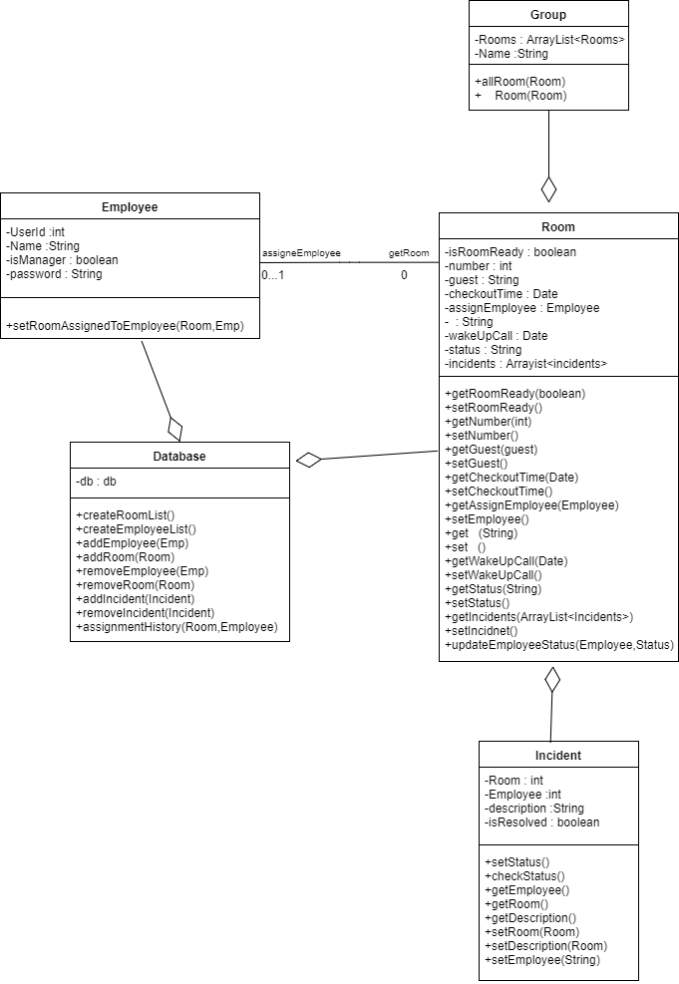Class Diagram:

Database Design:

